Global Economy: Brexit
Institution Affiliation
Name
Course

History of the UK’s Membership in the EU
The United Kingdom made its first application to join the European Union in 1961. It was rapidly apparent that there was a threat of political separation inside Western Europe, Commonwealth states were hurrying to do deals the new coalition, and it had American help. This application was vetoed by the French Government in 1963 with a subsequent application prohibited by the French again in 1967 (Campos & In Coricelli, 2017). It was uniquely in 1969 that the green light was given to dealings for British participation.
The United Kingdom joined the European Economic Community (as it at that point might have been) on January 1, 1973, with Denmark and Ireland. This demonstrated dubious at the time. The Labor party at first looked for renegotiation of participation. This was mitigated to requiring a choice on whether the United Kingdom ought to remain to be part of the Community (Campos et al., 2017). This submission was adequately held in 1975 with a 67% vote for proceeded with enrollment.
The Unified Kingdom was welcome to partake in talks which prompted the European Union's forerunners: the Treaty of Paris (1951) which built up the European Coal and Community and the Treaty of Rome (1957) which set up the European Economic Community and the European Atomic Energy Community (Campos et al., 2017). The British did not take part in a noteworthy manner with these discussions and signed neither bargain at the time.
They loathed a large number of the supranational and technocratic components in the bargains. They were stressed over harming joins with the Commonwealth, and they wished to seek after a 'one-world monetary framework' arrangement in which sterling was focal cash. The Unified Kingdom's non-interest in the European Coal and Steel Community and the European Economic Community toward the start implied than when England joined the European Economic Community in 1973 it needed to acknowledge numerous components that have demonstrated questionable with English voters: its supranationalism, normal agrarian arrangement, and spending plan (budget). These were altogether settled before the British united with the rest of the nations that formed the European Union (Campos et al., 2017).
Reasons why the UK want to change the Terms of Membership
The UK has been in the European Union for more than four decades. However, the UK has been seeking a way through which it can exit the Union. Thanks to the unexpected electoral victory by the Conservative Party. The Conservative Party is known for its traditional skeptical towards Europe (Boyle, 2015). The party seems to be making the referendum become a reality fast. However, this issue appears to be volatile in the past few weeks.
One of the reasons why the UK wants to leave the European Union (EU) is that they are claiming that EU is imposing so many rules on business and charging them billions of pounds per year in terms of membership fees for little return. The people who are voting against continuing of membership of the UK in the EU want the UK to make its own laws again, rather than following on laws that are created via shared decision making with the rest of the European countries. They are also claiming that the UK is remitting a lot of cash into the region's organization, and such money could be allocated to fund some other economic activities within the country (Boyle, 2015). It is the tradition of the EU union to support the more impoverished nation by remitting some cash which is used in the construction of infrastructures such as railways lines and roads within the poorer member countries.
Another reason making the UK exit the European Union (EU) is that of immigration. Immigration is of late a hot debated issue in many parts around the world, including the UK. When a country is declared a member of the European Union, it automatically allows citizens from the other member countries to enter the country without even having visas. These free movement of people makes the population of a particular nation increase, and once immigrants flock into a country, they might take up jobs that the native people could have taken up. Thus, UK's Brexit supporters want Britain to take back full control of its borders and thus decrease the number of individuals coming to live or even work in the country.
Legal Quandary
One point of convergence for supposed European command over UK laws is the impact of the European Court of Human Rights, which in certain prominent cases has made it harder to extradite outside conceived culprits. In the event that the UK moves from the ECHR's impact, it would be in an organization with disengaged Belarus as the leading European nations not to conform to it.
Should the United Kingdom remain a member of the European Union? Why? And Risks of leaving the European Union to the rest of Europe
Membership Fee; those who are championing for Brexit argue that leaving the European Union would immediately lead to cost-saving. Once the UK has left the EU will no longer contribute to the EU budget. The UK has been in the past few years been a significant contributor to the Union's budget. Some Brexiteers claim that there is a likelihood that the financial advantage of being a member of the Union such as inward investment, and free trade might not have been outweighing the upfront costs (The Week, 2019).
However, for the UK being a member of the EU meant that it had a say concerning how trade agreements were drawn up. But, once the country exits the trading union, it will no longer have a chance of influencing how the trading agreements will be drawn. More than 50% of the UK's exports go to EU countries. Thus, the state must be concerned with the consequences of leaving the European Union (The Week, 2019).
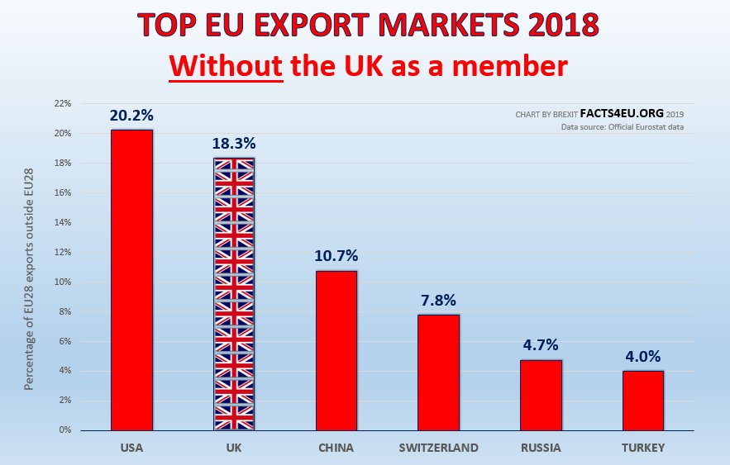
https://facts4eu.org/static/media/exports_2018_250319_without_uk.jpg
Another thing that will be impacted by leaving the European Union is an investment. UK is one of the globe's most significant financial centres that will mean that the transactions will be diminished if the city of London will be no longer viewed as a gateway to the European Unions for the likes of US banks (Perrigo, 2019). Also, the tax will drop once companies operating in the UK moves their headquarters into the European Union. Manufacturing companies based in the UK will also be negatively impacted since they will not export goods such as vehicles tax-free to Europe.
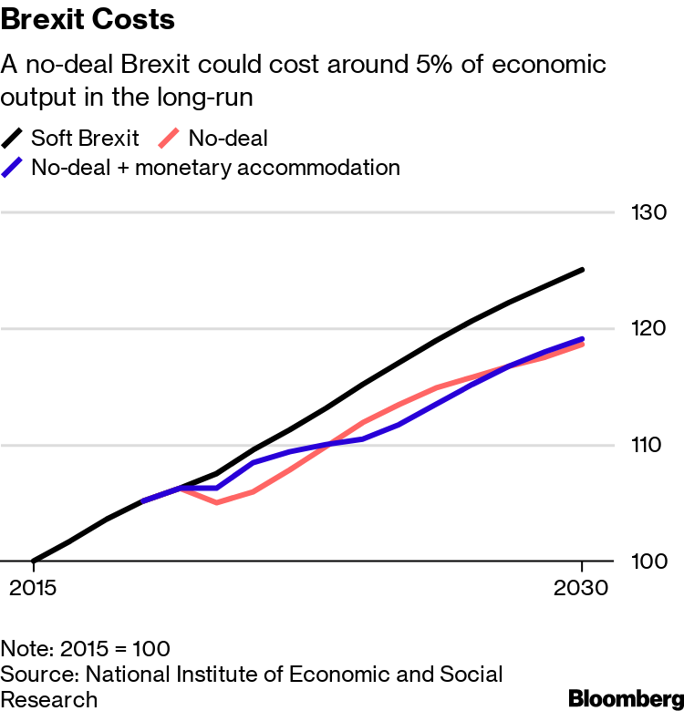
https://assets.bwbx.io/images/users/iqjWHBFdfxIU/iOvgX6Tjj8NU/v0/-1x-1.png
Conclusively, the above are just a few effects of Brexit. From the above-listed impacts of Brexit, it is clear that the UK will be affected by leaving the Union. For instance, the nation will no longer take part in decision making concerning trade agreements within the area (Perrigo, 2019). Also, it will collect fewer taxes compared to when it was a member of the EU, and most manufacturing companies might leave the country since they will not be in a position to export goods such as vehicles tax-free to other parts of Europe.

References
Boyle, C. (May 27, 2015). Just what is the UK’s problem with Europe? CNBC.
In Campos, N. F., & In Coricelli, F. (2017). The economics of UK-EU relations: From the Treaty of Rome to the vote for Brexit. Cham, Switzerland: Palgrave Macmillan.
Perrigo, B. (March 29, 2019). What Is Brexit? Answering Your Biggest Questions About the U.K.'s Plan to Leave the E.U. TIME.
The Week. (Feb 26, 2019). Brexit: pros and cons of leaving the EU. The Week.

